**COE Data Visualization**

**Previous Data**- The previous data that was being used were data used for identification, and being able to get that from surveys were helping us get demographics and understand what exactly they are looking for.

**Current Data**- The current Data that I am pulling out is the data I have collected from the Trello board that I have made three analyzations for based on various categories. The current data has shown the usage of how the Trello board was being used all throughout the semester. My objective is to show what observations

**Data Understanding-** The categories that I am looking at when I am trying to do the data analysis are the labels and the distinct count of card IDs. The labels are what are set up in Trello to help organize each person’s card and what exactly they need when they put down the specific tasks in Trello. The distinct count of card IDs are what they are using to make sure that

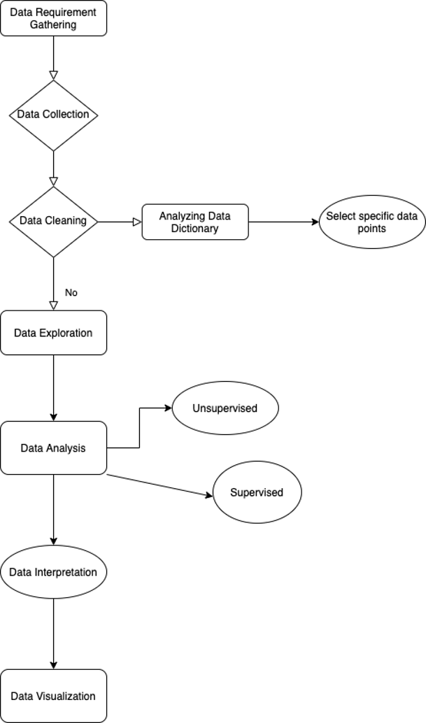

**Data Reporting**

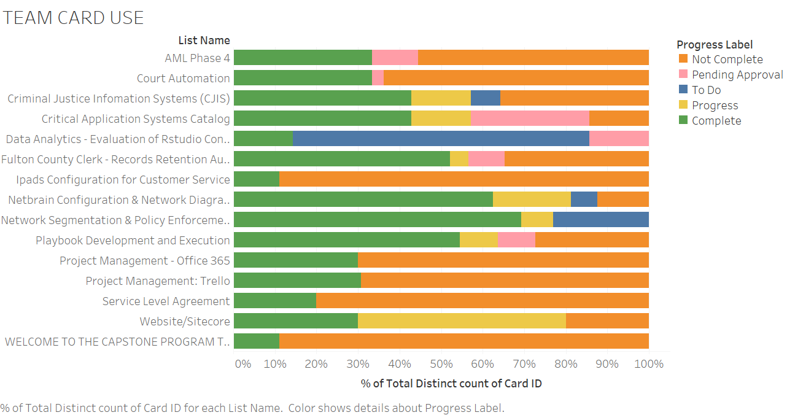

1. **Trello Card Usage:** Below is the graph created that shows how much usage went into Trello per team, based on their progress labels. The overall usage shows that Trello was being used well throughout the semester, with a handful of teams trailing behind and never really using Trello too much unless we had to push them.

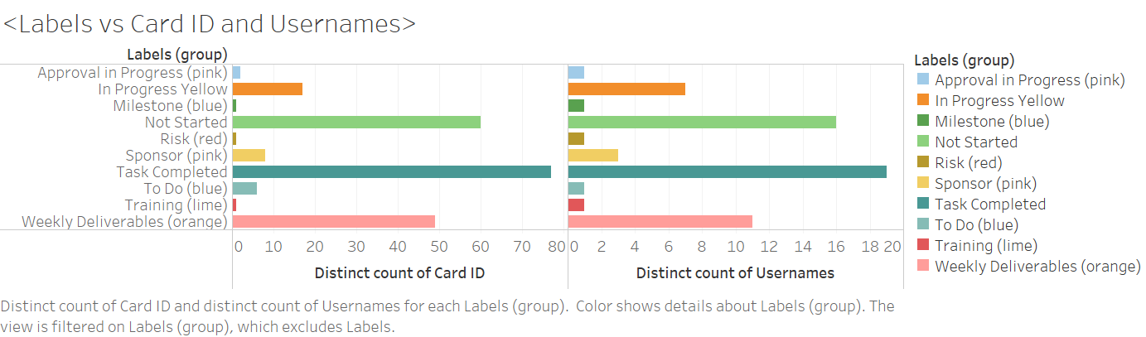

1. **Number of labels vs Card ID and username:** The graph shown here are what are the different kind of labels and what exactly the card ID’s I am finding. The labels that were used often included tasks they set for themselves which were not started, showing proactivity throughout the

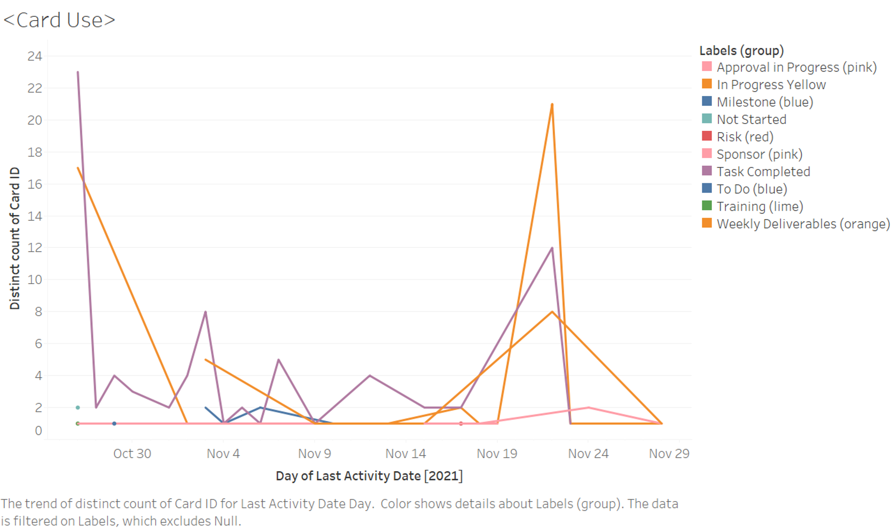

1. **Card Usage:** What is being shown here is the usage of various cards in a two-month span and when certain labels were being used. As seen here on October 30th there are many types of labels shown but the highest usage was the weekly deliverables and approval in progress because those were the cards that are the most important.